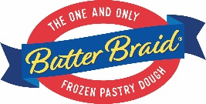
Fall 2024 Dates for Butter Braid Pastry Fundraisers

Don’t forget about Fall Break when choosing your dates!

Pre-Thanksgiving delivery
BB1
Start by 8/7
End by 8/21
Totals submitted by 3 PM on 8/23
Delivery week: 9/9 – 9/13

BB2
Start by 8/14
End by 8/28
Totals submitted by 3 PM on 8/30
Delivery options: 9/16 – 9/20

BB3
Start by 8/21
End by 9/4
Totals submitted by 3 PM on 9/6
Delivery options: 9/23 – 9/27

BB4
Start by 8/28
End by 9/11
Totals submitted by 3 PM on 9/13
Delivery options: 9/30 – 10/4

BB5
Start by 9/4
End by 9/18
Totals submitted by 3 PM on 9/20
Delivery options: 10/7 – 10/11

BB6
Start by 9/11
End by 9/25
Totals submitted by 3 PM on 9/27
Delivery options: 10/14 – 10/18

BB7
Start by 9/18
End by 10/2
Totals submitted by 3 PM on 10/4
Delivery options: 10/21 – 10/25

BB8
Start by 9/25
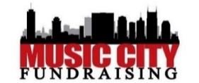
End by 10/9
Totals submitted by 3 PM on 10/11
Delivery options: 10/28 – 11/1

BB9
Start by 10/2
End by 10/16
Totals submitted by 3 PM on 10/18
Delivery options: 11/4 – 11/8

BB10 Limited Availablity
Start by 10/9
End by 10/23
Totals submitted by 3 PM on 10/25
Delivery: 11/11 – 11/15

BB11 Limited Availability
Start by 10/16
End by 10/30
Totals submitted by 3 PM on 11/1
Delivery: 11/18 – 11/22

BB12 Limited Availability
Start by 10/23
End by 11/6
Totals submitted by 3 PM on 11/8
Delivery options: 11/25

Pre-Christmas delivery
BB13
Start by 10/30
End by 11/13
Totals submitted by 3 PM on 11/15
Delivery options: 12/2 – 12/6

BB14
Start by 11/6
End by 11/20
Totals submitted by 3 PM on 11/22
Delivery options: 12/9 – 12/13

BB15
Start by 11/15
End by 12/2
Totals submitted by 12 PM on 12/2
Delivery options: 12/16 – 12/20

Sign up:
www.musiccityfundraising.com/signup
Or call 615-395-8051

